CIS 310 Group Project

Group Members: Queena Lin

Ruomei Wang

Andy Lin

Celeste Menard

John Chen

2. 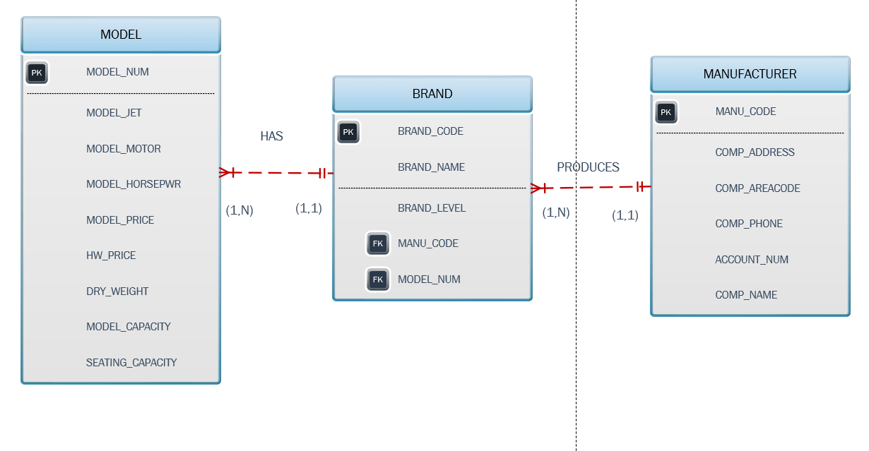

4.

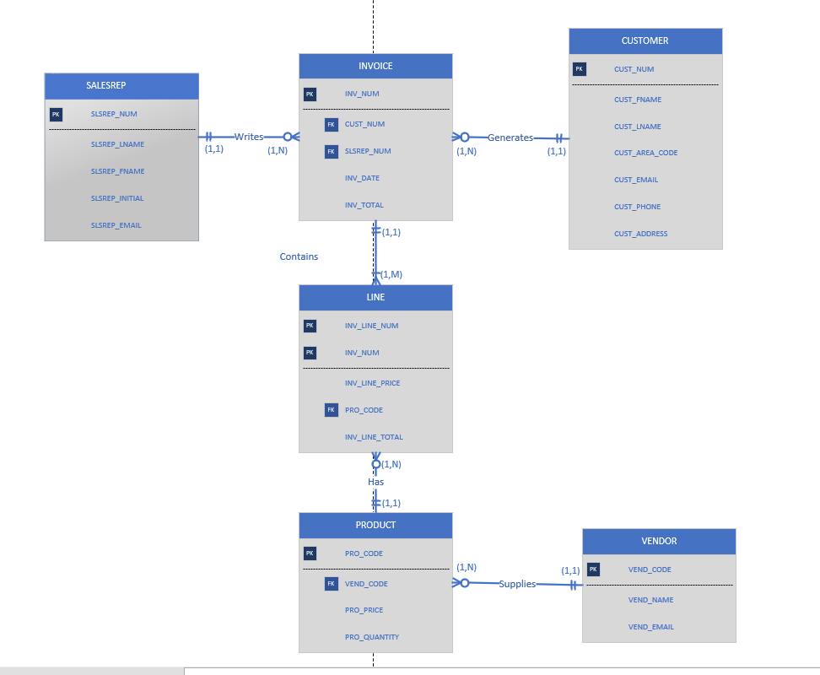

5. 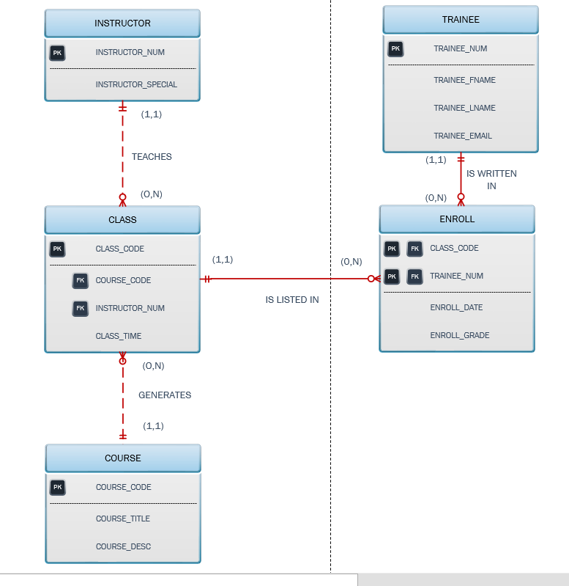

A. Define Entity and Relationship

* Entities: INSTRUCTOR, TRAINEE, COURSE, CLASS
* Composite entity: ENROLL

Relationship:

* COURSE generates CLASS but COURSE does not necessarily generate CLASS during training period, so CLASS is optional to COURSE.
* CLASS is generated by COURSE so in order for CLASS to exist, there must be a COURSE, so COURSE is mandatory to class.
* INSTRUCTOR may or may not teach a CLASS during enrollment period, so CLASS is optional to INSTRUCTOR.
* Not all TRAINEE would be ENROLL to a CLASS during certain period so ENROLL will be optional to TRAINEE,
* ENROLL cannot exist without TRAINEE so TRAINEE is mandatory to ENROLL.

B. Describe the relationship between instructor and class in terms of cardinality, connectivity and existence-dependence.

Connectivity:

* There is a M: N relationship between TRAINEE and CLASS so ENROLL is the composite entity that serves as a bridge to reestablish the relationship to 1: M.
* An instructor can teach to up to 2 CLASS and each CLASS can only have one INSTRUCTOR, so their relationship is 1: M.
* A COURSE may generate more than one class while each class is based on one course, so they have 1:M relationship.

Existence-dependence

* ENROLL and CLASS have a strong relationship and weak entity because the primary key of CLASS is also the primary key of CLASS. It is the same between TRAINEE and ENROLL. This means that they are weak entities which is existence-dependent from its parent entity.
* CLASS, INSTRUCTOR, and COURSE consisted of a weak relationship because the entity’s primary key was not inherited by its parent’s primary key.